**Data Cleaning**

Let's start by reading the csv file downloaded from Kaggle and understand the data.

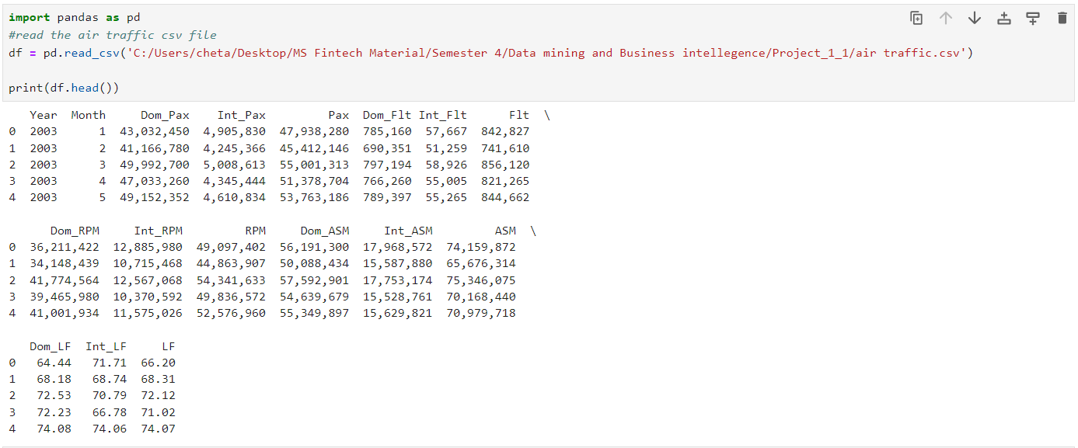

Let’s check for null values: We have no null values in the dataset

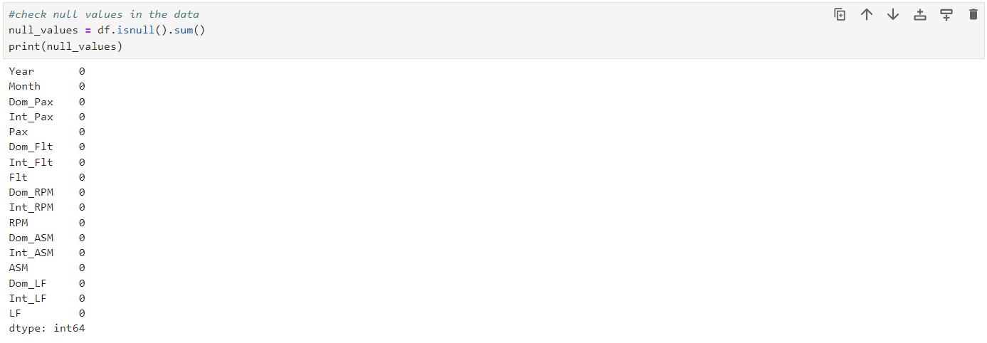

Let’s check the data types: we have numeric values and object types due to the presence of comma (,) in values in the csv file. We need to change these values into numeric to import it sas for forecasting.

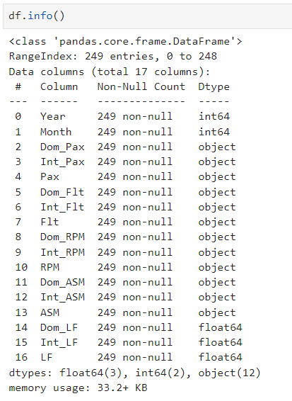

Let’s change the data type to numeric: As shown below we have changed all the data types to numeric.

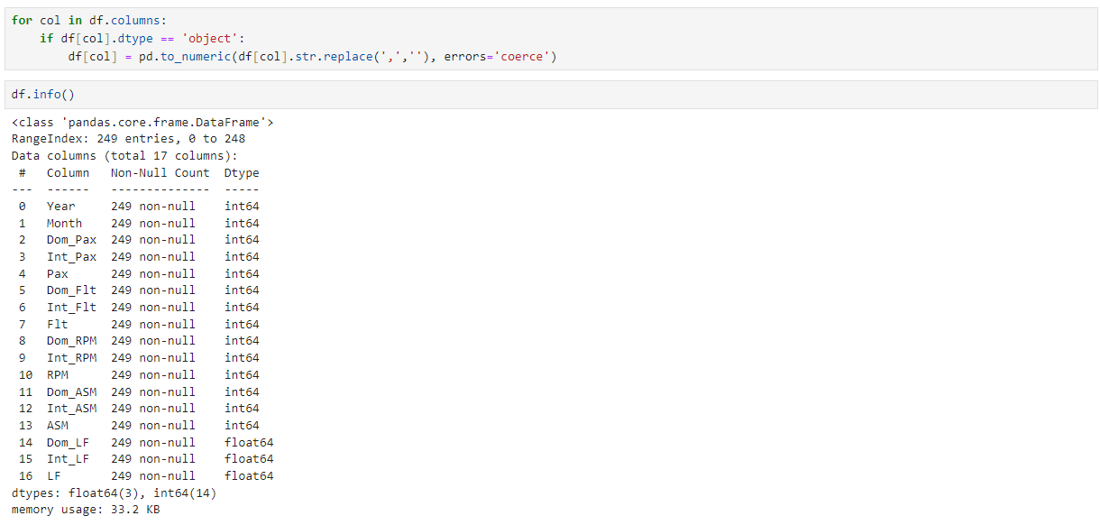

We have two variables ‘Year’ and ‘Month’, in order to use the data in SAS we need datetime format variables.

Let’s combine ‘Year’ and ‘Month’ to create a new variable ‘Date’ which is a supported date format by SAS.

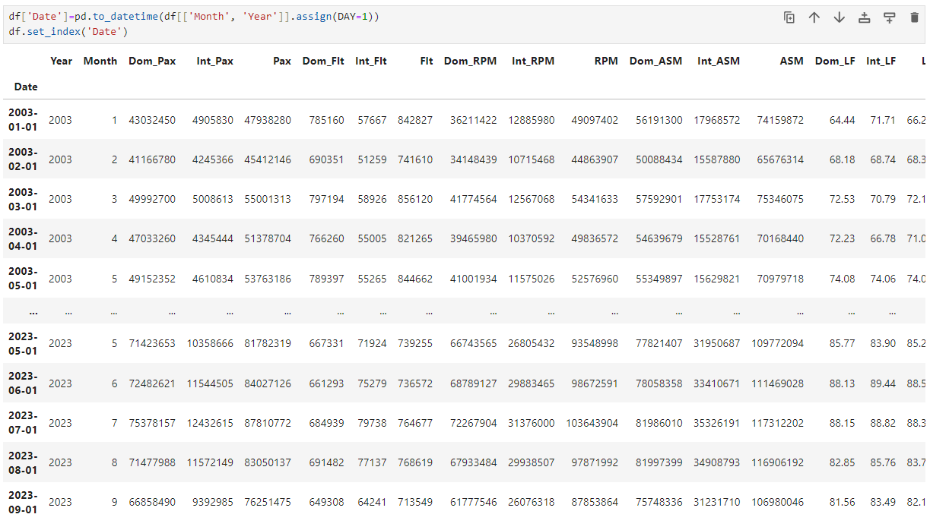

Let’s see how our dataset looks now and save it to the local drive as a csv file.

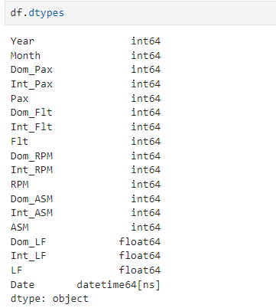

Saving the file to local drive to import in SAS.

